Write a C program to verify if a number is an Armstrong Number or not using Do...While loop.

#include<stdio.h>

int main()

{

int n,num,cube,sum=0,rem;

printf("Enter the number to be verified whether it is armstrong number or not\n");

scanf("%d",&n);

num=n;

do

{

rem = n%10;

cube=rem*rem*rem;

n/= 10;

sum=sum+cube;

}

while(n>0);

if(num==sum)

{

printf("The number is a armstrong number");

}

else

{

printf("The number is not a armstrong number");

}

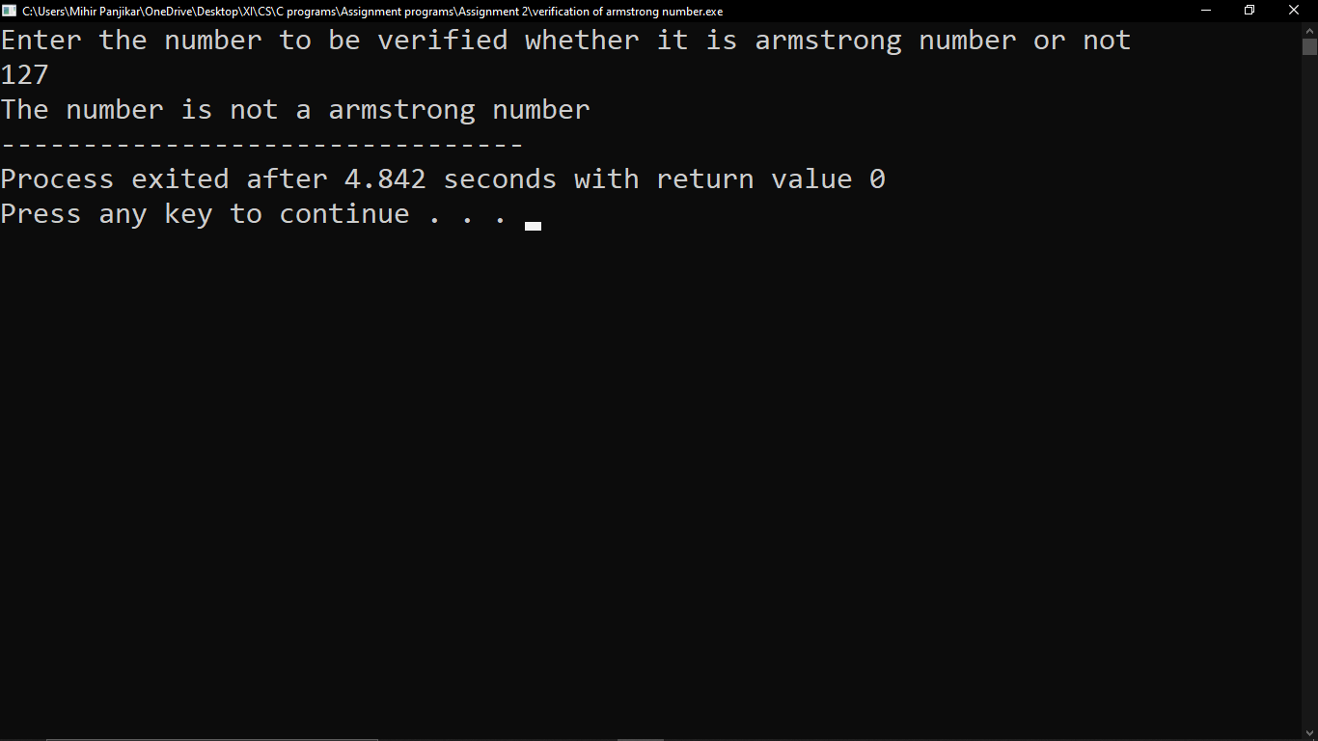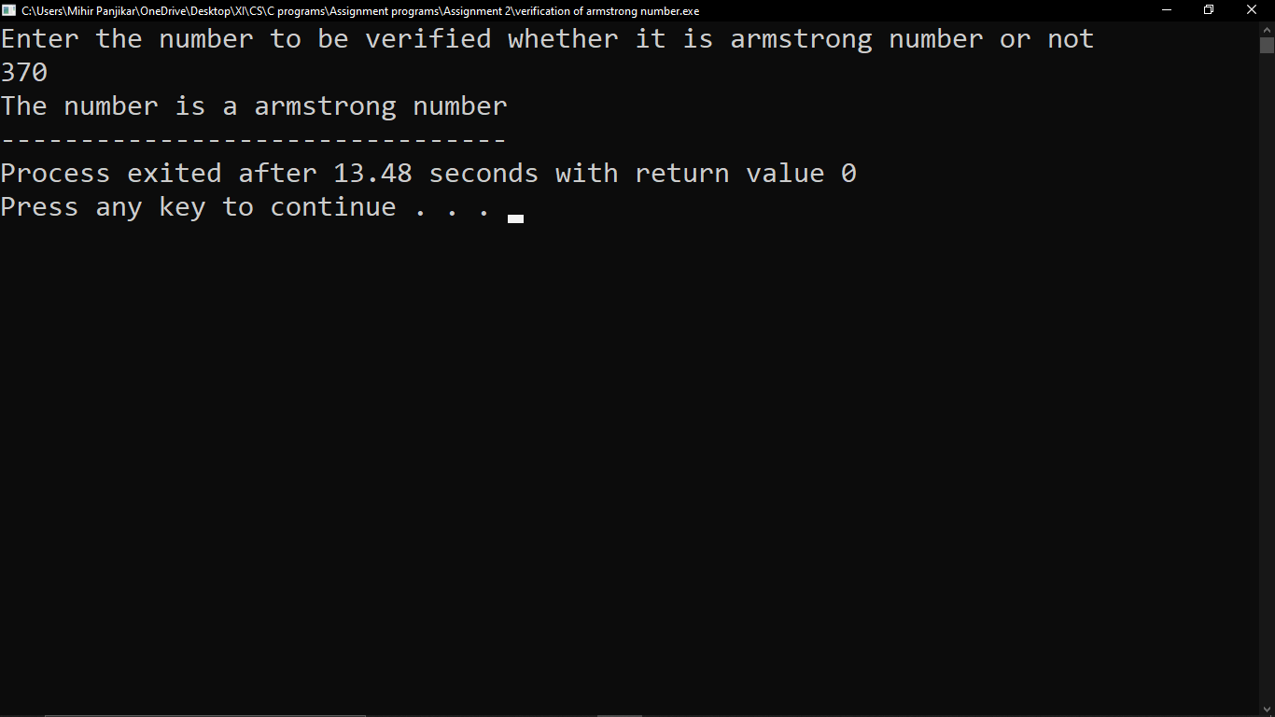}

Write a C program to determine the summation of first n even numbers.

#include<stdio.h>

int main()

{

int i=2,n,sum=0,count=1;

printf("Enter number upto which you want to add\n");

scanf("%d",&n);

do

{

sum=sum+i;

i+=2;

count++;

}

while(count<=n);

printf("\nThe sum of n number is = %d",sum);

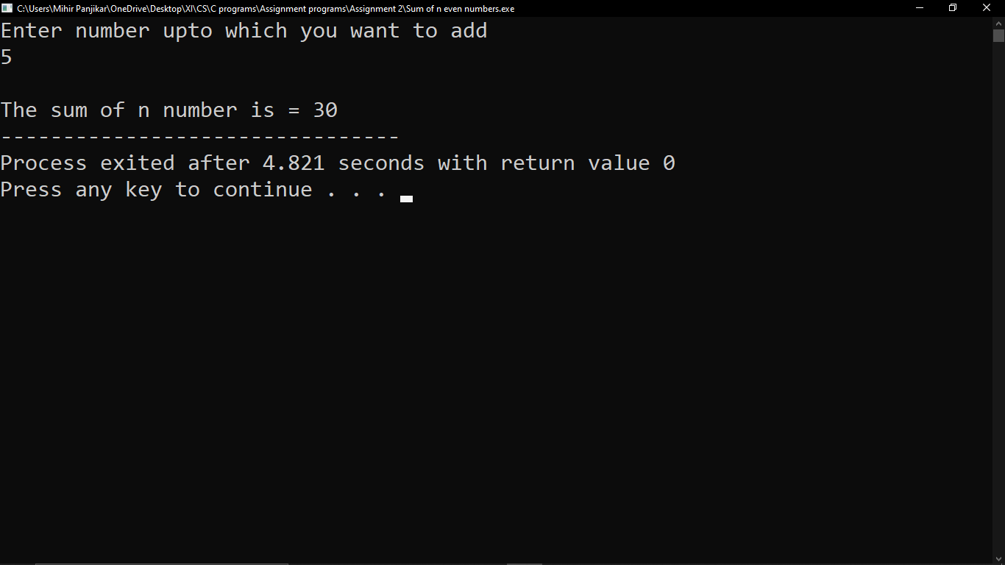}

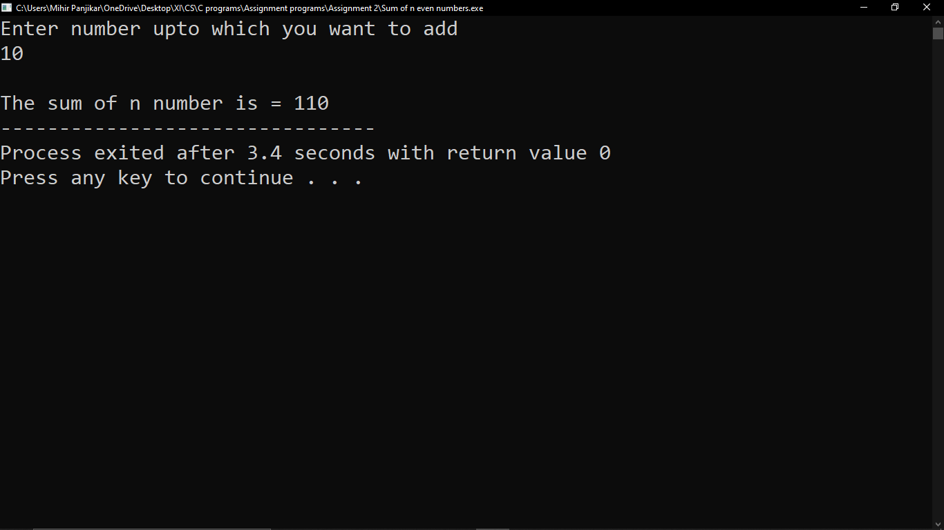

Write a C program to find the Factorial of a number.

#include<stdio.h>

int main()

{

int n,i=1,fact=1;

printf("Enter number to find the factorial of\n");

scanf("%d",&n);

for(i=1;i<=n;i++)

{

fact=fact*i;

}

printf("\n\nThe factorial of %d is = %d",n,fact);

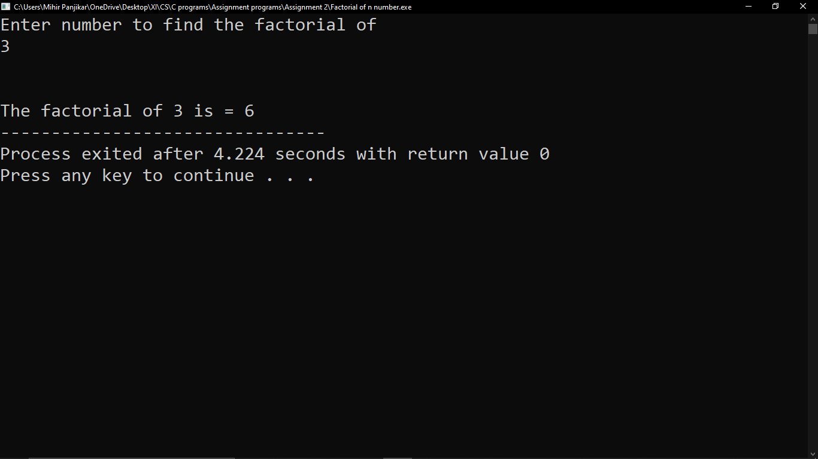}

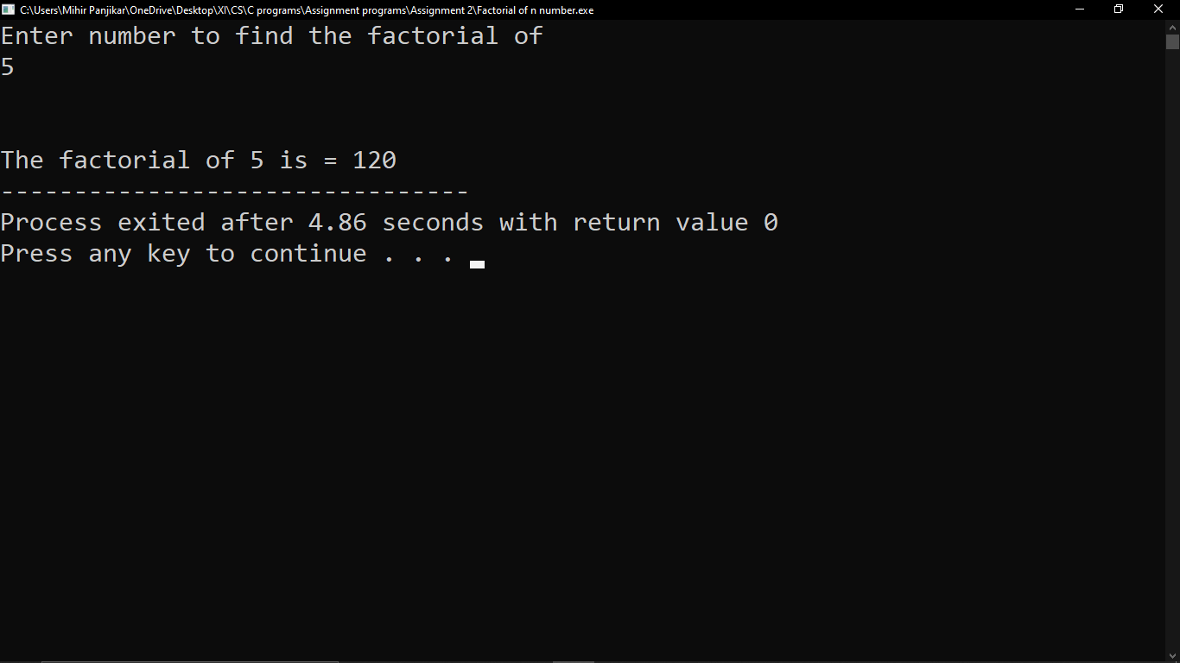

Write a C program to determine the summation of reciprocal of square of odd numbers.

#include<stdio.h>

int main()

{

int i=1,n,ori_squ,rev_squ,sum=0,rem;

printf("Enter the number upto which you want the sum of reverse square\n");

scanf("%d",&n);

while(i<=n)

{

ori_squ=i*i;

rev_squ=0;

do

{

rem = ori_squ%10;

rev_squ = rev_squ*10 + rem;

ori_squ /= 10;

}

while(ori_squ!=0);

sum+=rev_squ;

i+=2;

}

printf("The sum of reverse square of %d is = %d",n,sum);

